Sample scripts for ICE encounter / Know Your Rights role play

Scenario 1: A person on the bus is approached by an officer wearing a law enforcement jacket.

Officer: Hi ma’am/sir. Can I see your ID please?

Person: I do not need to show you anything based on my constitutional rights [and/or show Red Card] .
I have the right to remain silent [can provide name and DOB].
May I please go now?

Officer: [insistent, in a louder tone] I am a police officer, you need to follow my orders and show me your ID.

Person: [repeats firmly] I do not need to show you anything based on my constitutional rights,
[and/or show Red Card]
I have the right to remain silent.
May I please go now?
Or
Am I being detained?

Officer: [friendlier tone] How about this. What’s your name? Where are you headed?

Person: [*do not answer ANY questions!*] [repeats firmly] I do not need to provide any information to you, based on my constitutional rights.
[and/or show Red Card]
I have the right to remain silent.
May I please go now?

Bystander 1: [If rights appear to be violated, consider video documentation of interaction - eg ACLU Mobile Justice: app to record police conduct, automatically uploads to ACLU]

REASONS TO CALL SF RAPD RESPONSE NETWORK: Suspected ICE agent activity
Bystander 2: [call SF Rapid Response Network, (415) 200-1548; or report to UnitedWeDream National Hotline, 1(844) 363-1423]

Additional points: if physically accosted, do not resist. Ask to speak with lawyer.

END

Scenario 2: Someone knocks on the apartment door, stating they are police, asking to enter.

Officer: I have a few questions for you. May I please come in?

Person: *do NOT open the door!* You may not enter my home based on my constitutional rights. [or, slip Red card underneath door, or show card through window]

Officer: OK, I won’t go in. Can you come out here for just a second please?

Person: [*do NOT open the door!*] Do you have a signed warrant? I do not have to speak with you based on my constitutional rights. [and/or, slip Red card underneath door, or show card through window]

[Warrant - look for judge’s signature, official seal - samples attached]

Officer: [loudly, and banging on door] This is important! If you don’t open the door now, you are defying police orders!
Person: [*do NOT open the door!*] I do not have to speak with you based on my constitutional rights.

[Other tenants - go to their own rooms and shut the door, do not interact]

END

Scenario 3: An ICE officer enters ZSFG Children’s Health Center and asks for information about Individual ABC.

Officer: Good afternoon. I am with the police/ICE and looking for Mr. ABC - can you please help me?

[Ideally, Staff 1, 2, and 3 will act simultaneously]

Staff 1: Good afternoon. Do you have a warrant?
Staff 2: [to people in waiting area] Let’s go to a quieter, more private area. [move to another room, shut door]

Staff 3: [calls 6M RN/MD Clinic Managers to notify about situation]

Officer: I don’t have a warrant.
or
Here’s a warrant. [Appears unauthorized: doesn’t have Mr. ABC’s name listed, isn’t signed by a judge]

Staff 1: Per hospital policy, we are prohibited from sharing such information, and prohibited from allowing entry into our clinic. Can we step outside please?

[If Officer appears to have a legitimate warrant]
Per hospital policy, we must contact our supervisors first before any further action can be made. Please wait here in the meantime.

[If Officer is insistent or aggressive, firmly repeat the same response over and over.]

Other staff: [video documentation of interaction - eg ACLU Mobile Justice: app to record police conduct, automatically uploads to ACLU]

END
What a Raid/Encounter May Look Like

- Identifying ICE
  - Potentially looking for a specific person, group, or just generally sweeping the area
  - ICE agents may be in uniformed, armed, or dressed in plain clothes
  - Recommendation: If an unidentified person arrives as your hospital or clinic, ask them to identify themselves
  - Contact a supervisor BEFORE providing ICE agents with any confidential patient information
- Information you need to legally provide ICE
  - NOT legally required to provide ICE with information, unless they have a court order
  - If they present with a court order, contact supervisor (if applicable) BEFORE providing them with potentially confidential patient information
- Documentation from ICE – may have a FEDERAL/JUDICIAL warrant, or ADMINISTRATIVE WARRANT:

FEDERAL OR JUDICIAL WARRANT
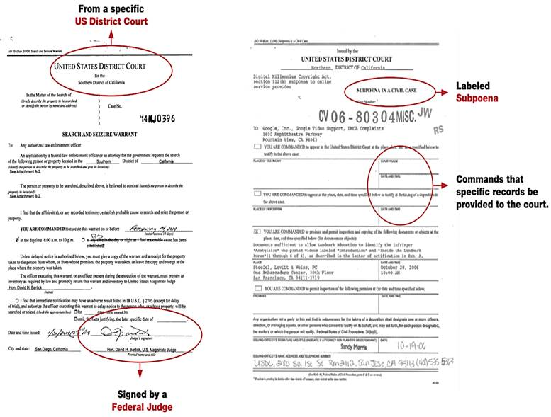

ADMINISTRATIVE WARRANT
- These are NOT issued by a judge and have NO legal authority
